Nalongsone Danddank Student ID : 14958950 StarID: jf3893pd

Email: [nalongsone.danddank@my.metrostate.edu](mailto:nalongsone.danddank@my.metrostate.edu)\

**ICS 432 - 01 — Distributed and Cloud Computing Fall 2021**

**Docker Lab :** Docker in AWS and GCP

Exercise 1: Docker in AWS with Python Flask

**Lab report screen-shot #1:**

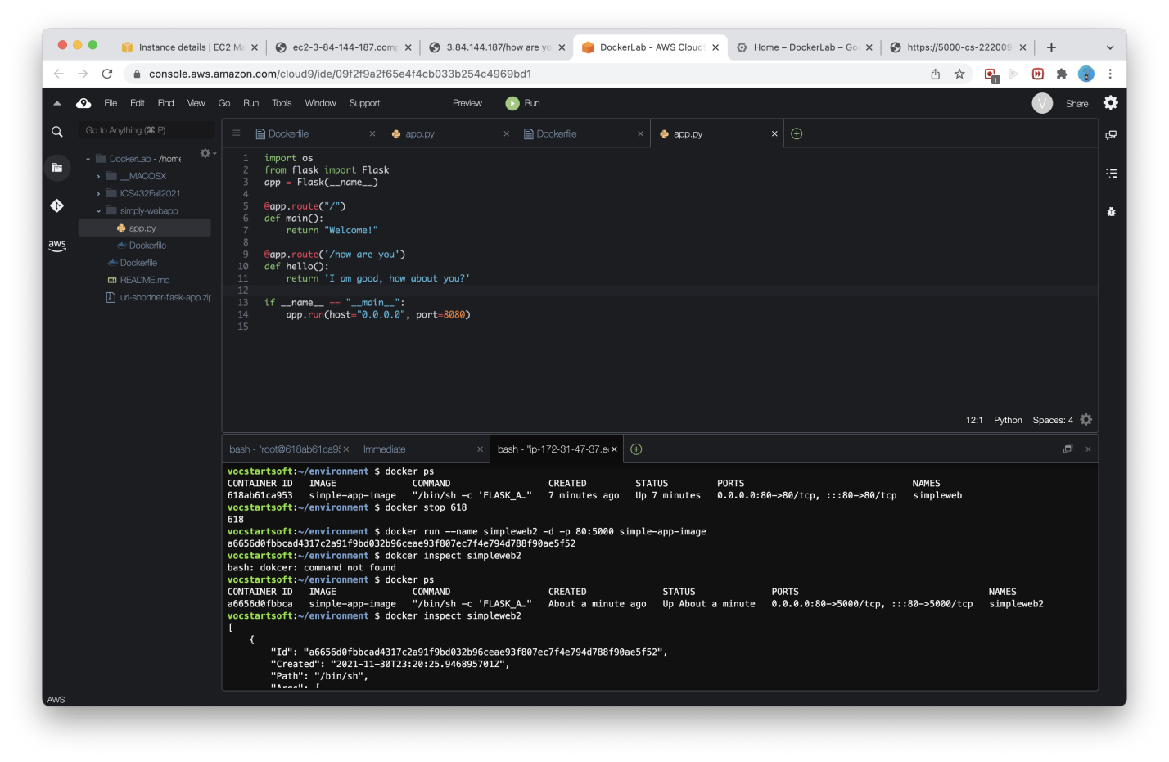

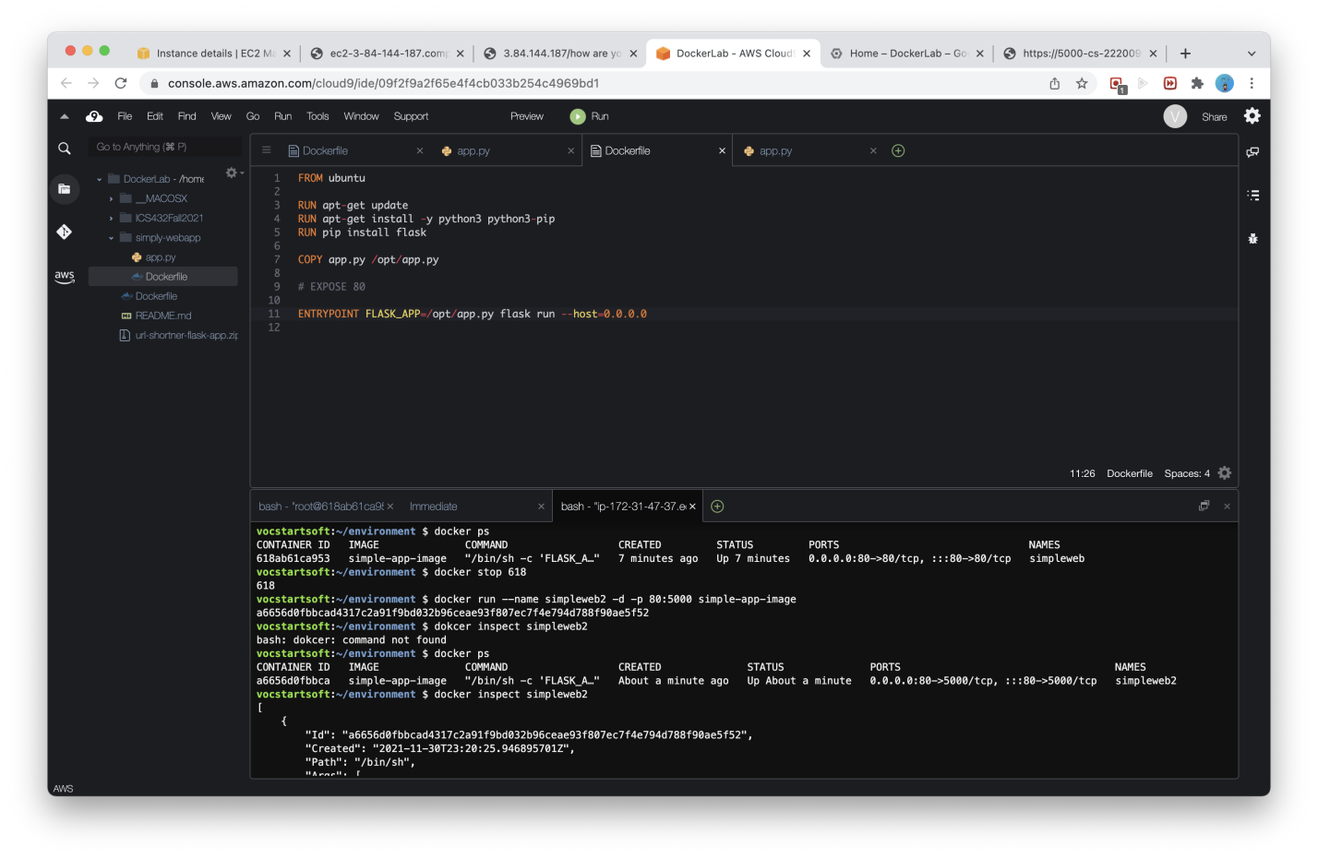

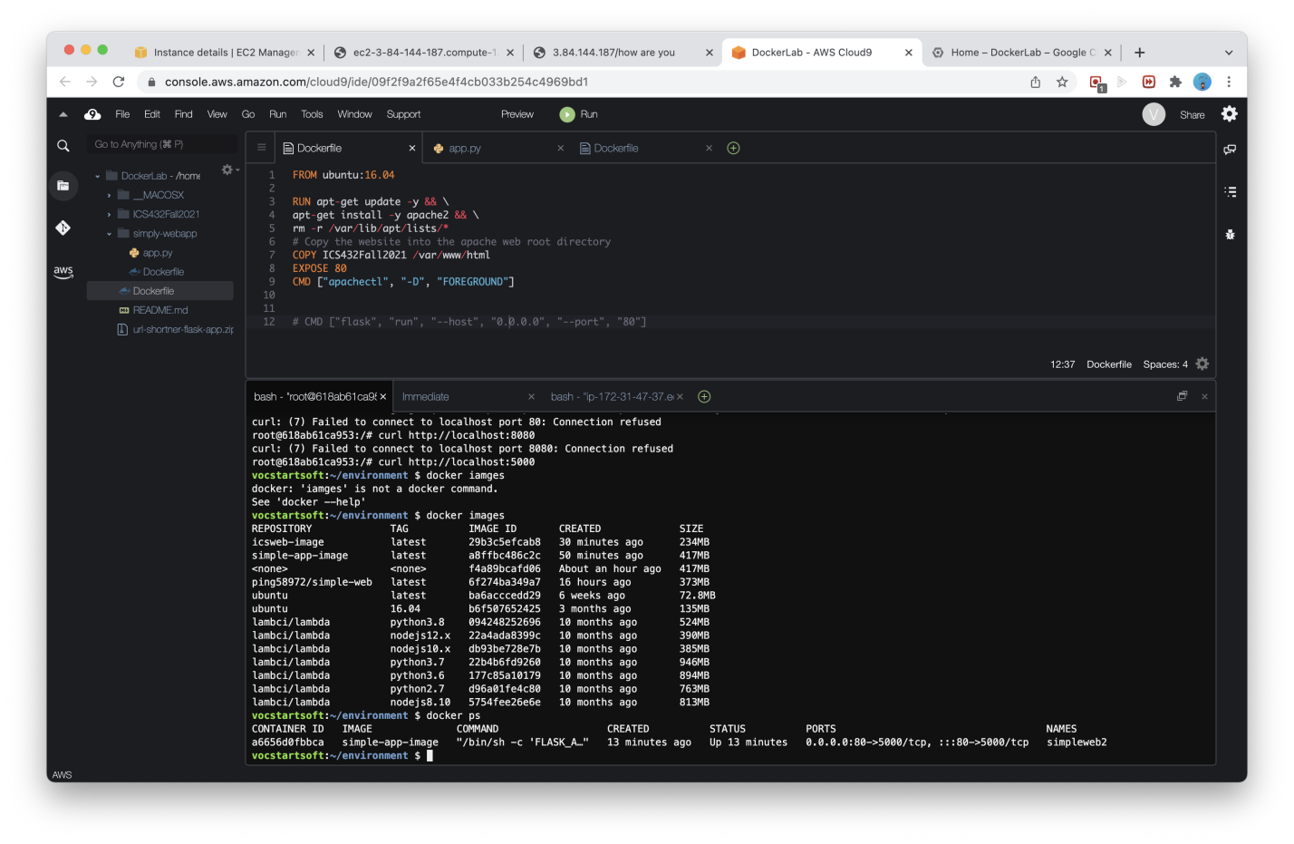

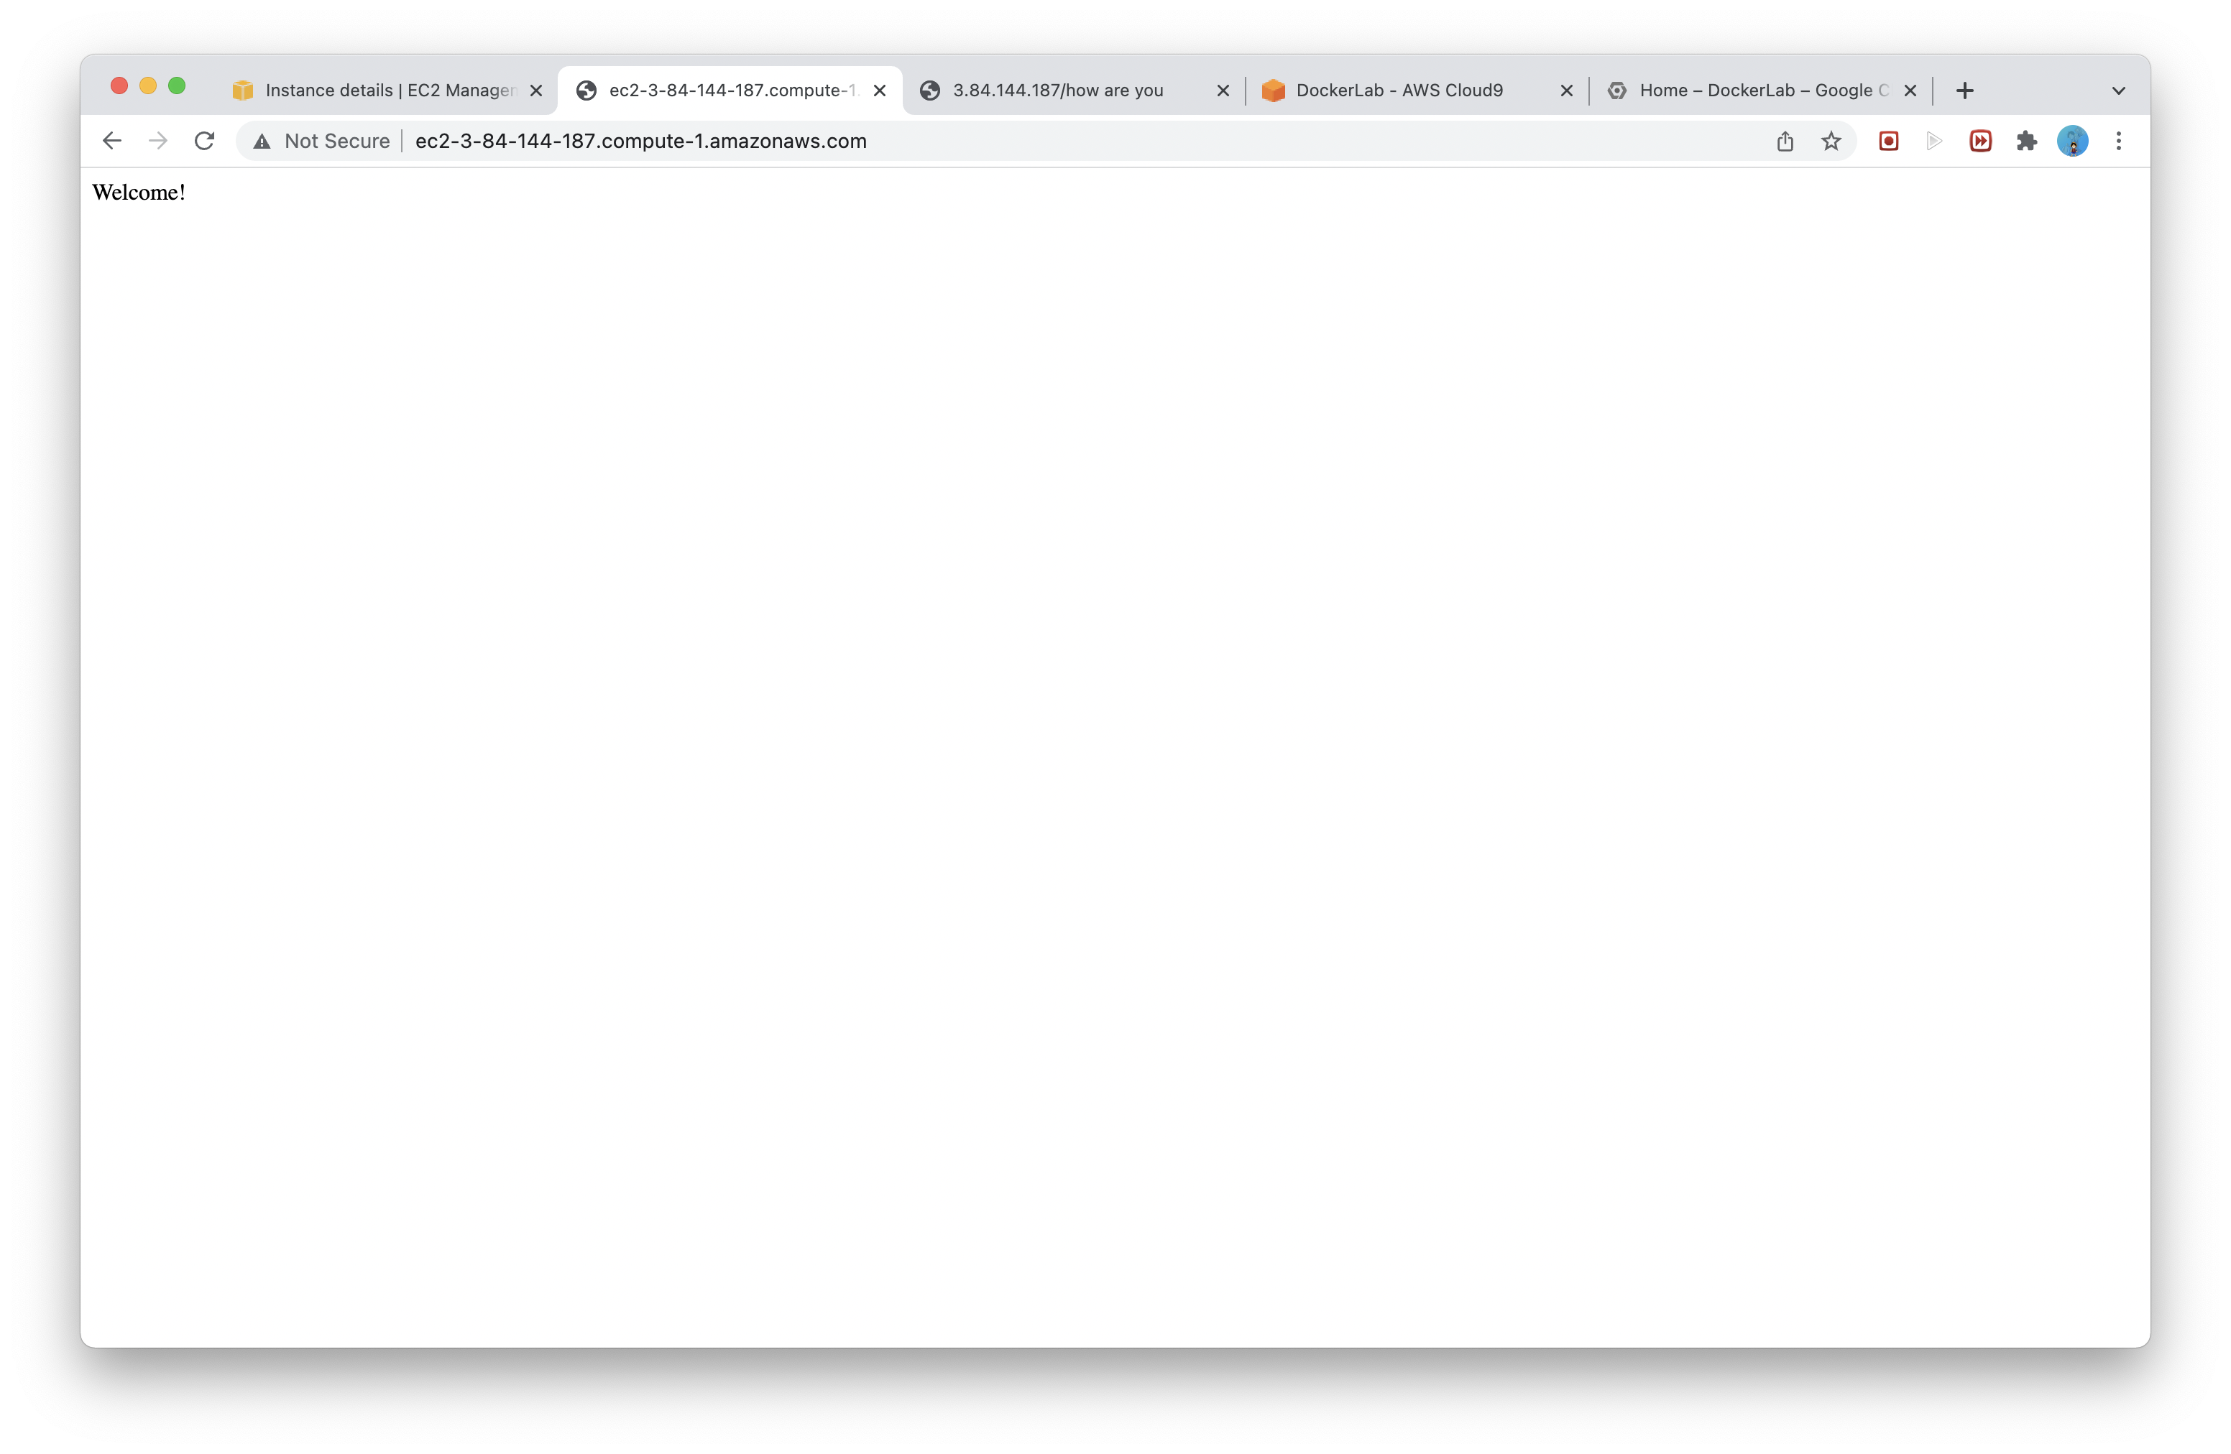

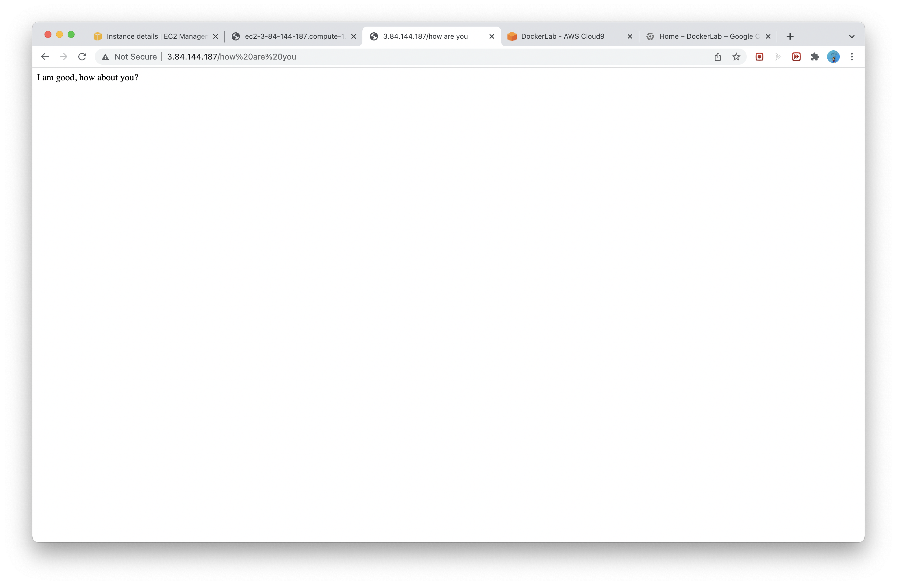

**Exercise 2:** Docker in GCP with Python Flask

**Lab report screen-shot:**

